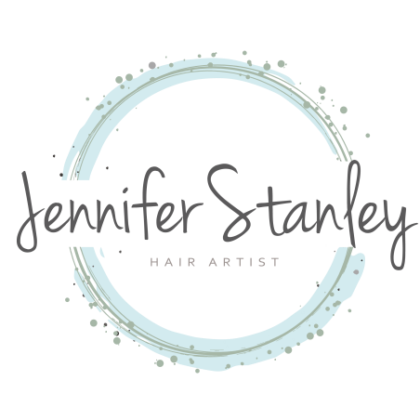

NBR™ Client Agreement Form

Pre-Appointment Acknowledgment
Client’s hair is at least at her shoulders.
Client’s shortest layer is no shorter than cheekbone.
Current hair photos as well as any inspiration photos were sent to stylist in advance of appointment.
A Phone consultation was made prior to scheduled appointment / / .
*Total cost may change if hair is different in person than what was discussed during consultation, or if the client’s wants or needs change during the appointment.

Client understands that Bohyme™ hair is the only hair used by the stylist, and for the NBR™ method.
Stylist guarantees the hair is always purchased directly from Bohyme™, therefore guaranteeing the authenticity of the hair.

Appointment Acknowledgment
Client acknowledges the authenticity of Bohyme™ hair.
Client acknowledges that the “NBR™ Home Care Maintenance Plan” was discussed in detail with the stylist and that a copy was retained for client’s use.
*Please note: the “NBR™ Home Care Maintenance Plan” is vital to insure optimal results.

Continued
Waiver and Idemnification
I, , per my phone or in salon consultation, and as memorialized and understood through the PRE-APPOINTMENT ACKNOWLEDGEMENT, APPOINTMENT AWKNOWLEDGEMENT, and the NBR™ HOME CARE MAINTENANCE PLAN, wish to proceed with the Natural Beaded Rows™ extension application.
I certify that the information I supplied to my stylist during the phone consultation, PRE-APPOINTMENT ACKNOWLEDGEMENT, APPOINTMENT ACKNOWLEDGEMENT, and NBR™ HOME CARE MAINTANENCE PLAN, are correct. I agree to indemnify and hold harmless, JENNIFER STANLEY and JENNIFER STANLEY HAIR for loss, damage, claims or actions of any type that I may suffer as a result of failure to provide accurate and complete information.
I agree that I will not hold JENINFER STANLEY or JENNIFER STANLEY HAIR liable in any way for any loss, damage, or injury suffered by me as a consequence of my use/ misuse of Natural Beaded Rows™ Hair Extensions.
I will indemnify and hold harmless, JENNIFER STANLEY or JENNIFER STANLEY HAIR free from all loss, damage, and claims actions of every kind that they incur or that are claimed or brought against them by any party as a consequence of my use of Natural Beaded Rows™ hair extensions.

Signature

Name Date

